**A**

**SIWES TECHNICAL REPORT**

**UNDERTAKEN AT:**

**KOGI STATE WATER BOARD(KGSWB)FELELE/GREATER LOKOJA WATER TREATMENT PLANT (GLWTP), GANAJA/AJAOKUTA ROAD, LOKOJA, KOGI STATE.**

**BY:**

**NDUBUISI JANE CHIBUNKEM**

**(SCI20ICH054)**

**INDUSTRIAL CHEMISTRY**

**FACULTY OF SCIENCE**

**FEDERAL UNIVERSITY LOKOJA**

**(JUNE – NOVEMBER 2024)**

**COVTECHNICAL REPORT**

**ON**

**STUDENT INDUSTRIAL WORK EXPERIENCE SCHEME**

**NDUBUISI JANE CHIBUNKEM**

**(SCI20ICH054)**

**UNDERTAKEN AT**

**KOGI STATE WATER BOARD(KGSWB)FELELE/GREATER LOKOJA WATER TREATMENT PLANT (GLWTP), GANAJA/AJAOKUTA ROAD, LOKOJA, KOGI STATE.**

**BY**

**SUBMITTED TO THE DEPARTMENT OF INDUSTRIAL CHEMISTRY FACULTY OF SCIENCE FEDERAL UNIVERSITY, LOKOJA IN PARTIAL FULFILLMENT FOR THE REQUIREMENTS OF INDUSTRIAL TRAINING.**

**FROM**

**JUNE TO NOVEMBER, 2024**

**DECLARATION**

I, Ndubuisi Jane Chibunkem declare that this write-up is a technical report of my activities and experience required during the SIWES period. This report is written by me under the supervision of Prof. Salehdeen Mohammed Umar. The information derived from the literature has been duly acknowledged in the text and a list of references provided.

**…………….......................... .........................**

**Signature Date**

**CERTIFICATION**

I certify that this is a technical report of SIEWS activities undertaken by Ndubuisi Jane Chibunkem at Kogi State Water Board (KGSWB) Felele / Greater Lokoja Water Treatment Plant (GLWTP), Ganaja/Ajaokuta Road, Lokoja, Kogi State.

……...…............................. …………………................

Prof. Salehdeen Mohammed Umar **Date**

**Institution-Based Supervisor**

……...…............................. …………………................

Prof. Salehdeen Mohammed Umar **Date**

**Head of Department**

**ACKNOWLEDGEMENT**

First and foremost, I appreciate God Almighty for how He helped me throughout my six months industrial training. Since I started the training I have not recorded a single case of accident and ill health.

My profound gratitude goes to my beloved parent Mr and Mrs Ndubuisi for supporting me through my education both morally and financially,

Also my gratitude goes to the institution based supervisor Prof. Salehdeen Mohammed Umar and the entire department students and lectures. Finally, I will not forget my Siwes colleagues; The entire FUL industrial chemistry department students, for the knowledge and experience we shared together.

**LIST OF FIGURES**

Fig. 2.2.1 A submersible pump. 9

Fig. 2.2.2 poly electrolytes dissolution & dosing tank. 13

Fig 2.2.3: Aeration of water 14

Fig.2.2.4: Well grating machine 15

Fig.2.2.5 flow splitter box 16

Fig 2.2. 6 Filter bed undergoing backwashing 21

Fig 2.2.7 Highlift pumps 23

Fig 2.3.11 Turbidimeter 32

Fig 2.3.12 Pocket pH meter 33

Fig 2.3.13 Mecury-filled Thermometer 33

Fig 2.3.14 Colorimeter 35

Fig 2.3.14 Flocculation/Jar test machine. 39

**TABLE OF CONTENTS**

Cover Page ……………………………………………………………………

Title Page ………………………………………………………………………

Declaration …………………………………………………………………….

Certification ……………………………………………………………………

Acknowledgement …………………………………………………………….

**CHAPTER ONE: INTRODUCTION**

1.1 History and Background of SIWES …………………………………..

1.1.1 General objectives of SIWES ………………………………..

1.1.2 Importance of SIWES ……………………………………….

1.1.3 The roles of industrial training fund …………………………

1.2 History and background of establishment …………………………...

1.2.1 History of greater Lokoja water treatment plant (GLWTP) ....

1.2.2 Mission of greater Lokoja water treatment plant ……………

1.2.3 Vision of greater Lokoja water treatment plant ………………

1.2.4 Aims/Objectives of greater Lokoja water treatment plant organizational structure of kogi water board, kogi state ………………………………

**CHAPTER TWO: KNOWLEDGE ACQUIRED DURING THE ATTACHMENT**

2.1 Units/ Stages Of Water Treatment in GLWTP ……………………….

2.1.1 The Intake Unit ……………………………………………….

2.1.2 The Chemical Unit …………………………………………….

2.1.3 Well Grating /Screening Unit. …………………………………

2.1.4 Flow Splitter Box ………………………………………………

2.1.5 The Clariflocculation Unit ……………………………………..

2.1.6 The Filter Unit ………………………………………………….

2.1.7 Clear Well Tank ………………………………………………..

2.1.8 Highlift Pump Station …………………………………………..

2.1.9 Generator House ………………………………………………..

2.1.10 The Power House ……………………………………………….

2.1.11 The Control Room Unit ………………………………………….

2.2 Water Quality Test (Laboratory Analysis) ……………………………….

2.2.1 Tests Carried Out In The Lab …………………………………….

2.3 Working Experience ……………………………………………………..

2.3.1 Water Treatment Process ………………………………………...

**CHAPTER THREE: PROBLEM ENCOUNTERED, AND SUGGESTIONS**

3.1 Problems Encountered …………………………………………………...

3.2 Possible Suggestions …………………………………………………….

**CHAPTER FOUR: SUMMARY, AND CONCLUSION**

4.1 Summary ……………………………………………………………….

4.2 Conclusion ……………………………………………………………..

**References**

**CHAPTER ONE**

**INTRODUCTION**

**1.1 HISTORY AND BACKGROUND OF SIWES**

SIWES was established by ITF (Industrial Training Funds) in the year 1973 to solve the problem of lack of adequate proper skills for employment of tertiary institution graduates by Nigerian Industries. The Students’ Industrial Work Experience Scheme (SIWES) was founded to be a skill training programme to help expose and prepare students of universities, polytechnics and colleges of education for the industrial work situation to be met after graduation. This scheme serves as a smooth transition from the classroom to the world of work and further helps in the application of knowledge. The scheme provides students with the opportunity of acquainting and exposing themselves to the experience required in handling and managing of equipment and machinery that are usually not made available in their institutions.

Before this scheme was established, there was a growing concern and trend noticed by industrialists that graduates of higher institutions lacked sufficient practical background for employment. It used to be that students who got into Nigerian institutions to study science and technology were not trained in the practical know-how of their various fields of study. As a result, they could not easily find jobs due to the lack of working experience.

Therefore, the employers thought that theoretical education going on in higher institutions was not responsive to the needs of the employers of labour. This was a huge problem for thousands of Nigerians until 1973. It is against this background that the fundamental reason for initiating and designing the scheme by the fund in 1973/74 was introduced. The ITF organization (Industrial Training Fund) made a decision to help all interested Nigerian students and established the SIWES program. It was officially approved and presented by the Federal Government in 1974. The scheme was solely funded by the ITF during its formative years but as the financial involvement became unbearable to the fund, it withdrew from the scheme in 1978. In 1979, the federal government handed over the management of the scheme to both the National Universities Commission (NUC) and the National Board for Technical Education (NBTE).

Later, in November 1984, the federal government reverted the management and implementation of the scheme to ITF. In July 1985, it was taken over by the Industrial Training Fund (ITF) while the funding was solely borne by the federal government. (Culled from Job Specifications on Students Industrial Work Experience Scheme).

**1.1.1 GENERAL OBJECTIVES OF SIWES**

SIWES is strategized for skill acquisition. It is in fact designed to prepare and expose students of universities, polytechnics and colleges of education to the real-life work situation they would be engaged in after graduation. Therefore, SIWES is a key factor required to inject and help keep alive industrialization and economic development in the nation through the introduction and practical teaching of scientific and technological skills to students. (Culled from Detailed Manual on SIWES Guidelines and Operations for Tertiary Institutions). Objectives of the Students Industrial Work Experience Scheme include:

1.Provide an avenue for students to acquire industrial skills for experience during their course of study

2.Expose students to work methods and techniques that may not be available during their course of study.

3.Bridging the gap between theory and practice by providing a platform to apply knowledge learnt in school to real work situations

4.Enabling the easier and smoother transition from school by equipping students’ with better contact for future work placement

5.Introduce students to real work atmosphere so that they know what they would most likely meet once they graduate.

**1.1.2 IMPORTANCE OF SIWES**

All Nigerian students who study technology and science must know about SIWES. Partaking in SIWES has become a prerequisite for the award of diploma and degree certificates in many Nigerian Institutions according to the Nigerian government Educational policy. Undergraduate students of the following disciplines are expected to be a part of the scheme: Natural sciences, Engineering and Technology, Education, Agriculture, Medical Sciences, Environmental, and pure and applied sciences. The duration is for four months and one year for polytechnics and colleges of education students respectively and six months for university students.

**1.1.3 THE ROLES OF INDUSTRIAL TRAINING FUND**

The industrial training fund performs the following roles:-

The fund identifies and prepares suitable industries for placement of student.

* Collects list of eligible student for payment of student allowances through their employers and institutions.
* Examines periodically at work, student practical assignment and the signing of log books.
* Enhances academic excellence with creative education.

**1.2 HISTORY AND BACKGROUND OF ESTABLISHMENT**

**1.2.1 HISTORY OF GREATER LOKOJA WATER TREATMENT PLANT (GLWTP)**

Greater Lokoja Water Treatment Plant(GLWTP) construction and operation project is located in Ganaja Village Lokoja, the capital of KOGI state, which is an important junction in Nigeria’s north-south traffic. The project includes a purification treatment plant, a high pool tank A, with water storage capacity of 10,000cubic meters, a high pool tank B, with storage capacity of 3,000cubic meters, a compressor station and over 20-kilometer long of ductile pipe. Upon completion, the project will solve the drinking water problems that concern 10 million people in Lokoja, substantially improving the local living environment and giving strong boost to the region’s economy.

Greater lokoja water treatment plant was established in the year 2011 and was commissioned on 28 Nov, 2011 by former president i.e Dr. Goodluck Ebele Jonathan under the Governorship of Alhaji Ibrahim Idris. The construction company was Chinese Geological Company (CGC) and the client who awarded the company was Kogi State water resources and rural development. It was been managed from the very point of construction by the construction company to 2016.Then Kogi state water resources and rural development took over on 16 Oct, 2016 till date. It has a production capacity of 10 million gallons per day which is equivalent to 50,000 cubic meters. This water plant supplies water to Lokoja metropolis. It has two booster stations one at Ganaja junction and the other along Mount Patti. The tank A distributes water to tank B along mount Patti road and both of the booster station distributes water to the populace. The source of raw water is gotten from the river Niger and passes through series of purification stages before the purified water is obtained.

**1.2.2 MISSION OF GREATER LOKOJA WATER TREATMENT PLANT**

The project mandate is to conduct quality treatment and purification of raw water from River Niger (raw water source) for consumption by the people of the Lokoja and environs. The specific mandates of Greater Lokoja Water Treatment Plant;

1. Treatment of water according to the World Health Organization (WHO) standard of drinking water.

2. Supply portable water to Lokoja residents and environs every day.

**1.2.3 VISSION OF GREATER LOKOJA WATER TREATMENT PLANT**

There are two main source of water. These are underground water and surface water. Greater Lokoja water treatment plant uses surface water which is river Niger as it source of raw water. The people of Lokoja want water that is free of bacteria, sparkling clear and without and objectionable taste or odor. River Niger in its natural states hardly ever has these qualities. So after water is drawn from the source (River Niger), it is piped into the treatment plant. The plant put the water through several processes which last for at least eight (8) hours.

The four basic processes are: chemical dosing/mixing, disinfection, coagulation and settling,

filtration.

**1.2.4 AIMS/OBJECTIVES OF GREATER LOKOJA WATER TREATMENT PLANT**

The main objectives of greater Lokoja water treatment plant are:

1.To convey water to people of the communities.

2.To develop a skilled, highly motivated and dedicated work force.

3.Provision of safe and portable drinking water.

4.Provide water for commercial services e.g. to the producers of sachet water, table water, institution.

5.Provision of employment to reduce the rate of unemployment in the state.

**ORGANIZATIONAL STRUCTURE OF KOGI WATER BOARD, KOGI STATE**

**CHAPTER TWO**

**KNOWLEDGE ACQUIRED DURING THE ATTACHMENT**

**2.1 UNITS/ STAGES OF WATER TREATMENT IN GLWTP**

**2.1.1 THE INTAKE UNIT**

This is a concrete pie intake facility with a passage, the intake pump station is designed to deliver raw water to the treatment plant with a capacity range to match the plant design. The source of the raw water is river Niger(surface water). The water is drawn with the help of a submersible pump which is submerged to about 15 meters down the river. We make use of four(4) submersible pumps but due to the nature of power voltage, we make use a maximum of 3 and minimum of 2. Each of these submersible pumps is connected to a galvanized iron pipes(G. I pipes) of 800mm in diameter and has a flow rate of 917m³/hour. These pipes are synchronized to form two larger pipes with a gate valve which regulates the flow of water.

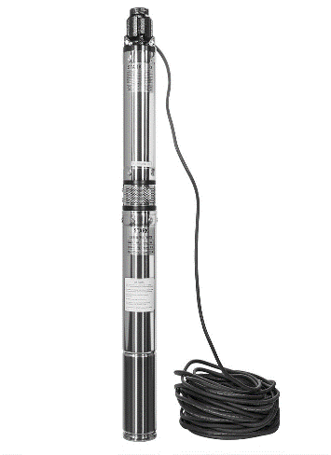

**Fig. 2.2.1 A submersible pump.**

**OPERATIONS OF THE INTAKE UNIT**i. Check to ensure there is power in the local operation box.

ii. When pumping water from the intake ensure the outlet valve is open.  
iii. Do not start pump when the voltage is below 400V.  
iv. Always open or close pump and valve while on manual.  
v. Record the current and voltage of pump per hour.  
vi. In case of any failure of machine, the power should be put off and report to the plant engineer.  
vii. Stop operating while thundering

**2.1.2 THE CHEMICAL UNIT**

The chemical unit as the name implies is basically for chemicals. It is where chemicals are stored and also where solutions are prepared and dosed appropriately. These chemicals may be solids (granules, pallets, blocks and powdery) so it has to be changed from its solid state to molten or liquid state so that it can be easily dosed.

The facilities in the chemical unit include

1. Chemicals

* Aluminium sulfate [Al2(SO4)3]: Alum exist inform of blocks and or pallets and its whitish in color. It has a net weight of 50KGS. This chemical serves as primary coagulant.
* Calcium hypo chlorite [Ca(ClO)2]: This 70% calcium hypo chlorite is inform of granules. It has a net weight of 45KGS per container. The chemical serves as disinfectant to kill and make most micro organisms in water inactive.
* Calcium hydroxide [Ca(OH2)]: commonly known as lime is in powdery form, whitish in color and has a net weight of 25KGS per bag. This chemical serves as pH corrector. It brings the pH to neutral; the recommended W. H. O standard for portable water.
* Poly Electrolytes (super flocs) : A polymer, long chain of synthetic organic compounds. It is also added to the water as a coagulant and to help in strengthening the primary coagulant bonding chain there by bringing about effective coagulation during a peak period of turbidity.

2. Dissolution tank/pool (for each chemical)

3. Dossing pumps

4.Local control box

5.Blender/Agitator mixer.

**PREPARATION OF SOLUTIONS**

Solutions are prepared by dissolving the chemicals in a solvent (water). Firstly we look at

dissolution tank /pools.

The dissolution tank /pool here In GLWTP is such that the tank is double. The first has the

following :

* Blender /Agitator mixer: which help in mixing chemicals to dissolve fast and completely.
* Plastic filter: Is a plastic that have small holes on it, which prevents the passage of un dissolved chemicals from the first one to the second one.
* Water inlet valve which is open when water is required for the preparation of solution to be used.
* Over flow: when the pool is over-full, the water flows through over flow.
* Drain valve: This is used when washing the pool, after washing, the drain valve is open

for the water to flow out.

* Pipe that connect to the second pool.

The second pool have all the blender /Agitator, water inlet, overflow, drain valve and also electric sensor that sense and give out a digital reading of the volume of solution in each tank. And is the second tank that is connected to the dossing pumps.

**HOW TO PREPARE SOLUTIONS**

Alum solution ;

* Close the drain valve and the valve leading to the second tank.
* Open water inlet valve and wait for the pool to be half or one over four(1/4) full.
* Pour in six(6) 50KGS bags of Alum into the water and start the Blender /Agitator mixer and close the water inlet valve if the pool is full.
* Wait for about 45min - 1hr for the Alum to dissolve completely.
* Open the valve leading to the second pool

**Note:**

Same procedure is applied when preparing hydrated lime and calcium hypo chlorite solutions.

Poly electrolytes solution

* Pour the poly electrolytes into the feeding tank.
* Switch on the local control box.
* From the local control box panel, press feed water "ON", Dry feeder "ON" and also the two Agitator mixer "ON".
* The poly electrolytes will be dropping from the feeding tank into the dissolution tank

while the mixer mixes it to dissolve.

* Observe carefully to stop both feed water, dry feeder and the two Agitator mixer when

the tank is full.

**Dosing pumps**

The dosing pumps are electric machines connected to the second pool that dose the chemical solutions base on the frequency set.

**Operation:**

The pumps are operated automatically from the control room and manually.

**To operate manually:-**

* Open all valves except that of water and those not in use
* On the local control box, turn the remote cut to "2".
* Press green "start" button to start the pumps. The pumps are three in numbers, you

can start one, two or all base on how the treatment will be.

* Press red "stop " button to stop the pumps.

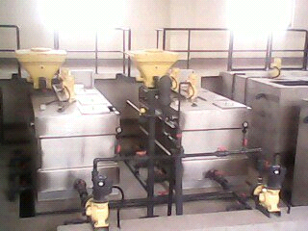

**Fig. 2.2.2 poly electrolytes dissolution & dosing tank.**

**Attention**

* After every treatment, open water for about half an hour to wash out deposited chemical to avoid blockage.
* Always wear protective clothing, filter mask, and hand gloves when preparing solution

to avoid inhaling or contact with the chemicals.

* Proper attention is required to all facilities so as to notice any fault which may cause damage.
* Report immediately any fault noticed for urgent attention.

**2.1.3 WELL GRATING /SCREENING UNIT.**

This is the point of contact of the raw water from intake unit and the dosed chemical from chemical unit. Coagulation, flocculation and Sedimentation takes place immediately. Aeration: In this stage, the raw water mixes with atmospheric oxygen. The minerals in it becomes oxidized, Fe2+ and Mn2+ are removed during aeration by the Cascade aerator i.e. they are oxidized to their higher valences and precipitate as insoluble form. Not this alone, odour producing substances like H2S, CO and Volatile oil which are liberated by the composition of algae growth are also removed. The removal of CO2 from raw water prevents corrosion; that means taste is removed during aeration. Hydrogen sulphide (H2S) is a constituent of Raw water that has not been exposed to the atmosphere. Where H2S is a problem, it can be removed by Aeration. Generally, the main purpose of aeration is to remove dissolved gases, odour, and colour. The process of aeration is carried out in the grating well.

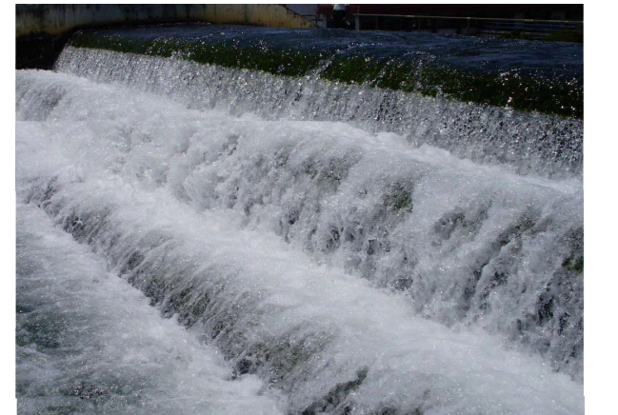

**Fig 2.2.3: Aeration of water**

A well grating/screening machine: this is often regarded as the first stage in water treatment. As the raw water is coming through the channel, it is allowed to pass through a screen bar; this screen bar is a chain-like machine rotating uoward. This process is to remove large floating objects from wastewater. The bar screen (bar screen) is installed ahead of pumps to prevent clogging. The materials removed usually consist of wood, rags, cans, plastic packets etc. that will not putrefy. These solids are removed and disposed by incineration of in a landfill. Screening helps in preventing damages caused by solid materials on pumps.

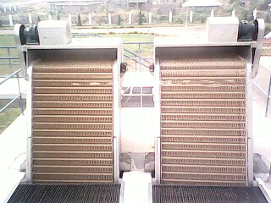

**Fig.2.2.4: Well grating machine**

**2.1.4 FLOW SPLITTER BOX**

This is a concrete well basin in which water from the well grating unit flows into the splitting

box in order to split the water into three(3) different clariflocculator. It reduces the gravity of

the water in order to attain excellent sedimentation.

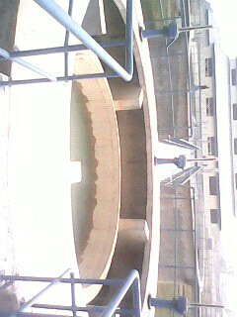

**Fig.2.2.5 flow splitter box**

**2.1.5 THE CLARIFLOCCULATION UNIT**

The round shape concrete well basin of about 27m in diameter are mainly designed for clarification and flocculation. It is built with mechanical means for continuous removal of suspended solid particles(flocs) that are in higher concentrations. The clariflocculators are made up of some components :-

* Blender/Agitator mixer which mixes up the raw water and the chemicals already added

to it, for clarification and flocculation to take place.

* Scraper is designed in such a way that the scraper hand/blade is almost towards the circumference of the clariflocculator. It helps in scrapping sludge settled at the bottom of the clariflocculators.
* Sludge box: a provision (hole) at the bottom of the clariflocculators where sludge scraped by the use of the scrapper is collected.
* Local control box: where the scrapper, mixer and sludge recircle pump can be operated manually by turning the remote cut to the left and pressing "start" for any of the machines you want to operate and also press "stop" if you want to stop any of the machines.
* Central pier/flocculation zone: is the center of the clariflocculators where the mixer is, and where flocculation takes place and also where the scraper is situated.
* Ware mage/collection channels : these are channels in which the supernatant is collected passing through the pipe that leads to the filter.
* Sludge recircle pump: is a machine for sludge recirculation, back into the central pier/flocculation zone, to be use again considering the fact that the sludge may still have chemical content in it.

**PROCESS /FUNCTIONS OF THE CLARIFLOCCULATORS**

The clariflocculator as another unit of the water treatment plant is a place where almost all the treatment take place. It is divided into central pier /flocculation zone and supernatant zone. The mixture of raw water and the chemicals from flow splitter box enter the flocculation zone, where the blender /Agitator mixer act on the water by mixing steadily and also breaking the long chain hydrocarbon (poly electrolytes) so as to react fast with the flocs and become more heavier. The heavier suspended solid settle in the clarifier due to the quiescent condition(motionless) provided in the supernatant zone. The settlement(sedimentation) is accomplished by decreasing the velocity of the water below the point where it can transport settleable suspended particles, thus allowing gravitational forces to remove particles held in suspension. When water is still in clarifier basin, settleable solid will move toward the button of the basins. The process of sedimentation removes almost 90% solids in the water. The clarified water(supernatant) comes up and flow through ware mage/collecting channels down the filter gallery to remove the remaining 10% of suspended solids. Over a time, the settled particles then form a layer of sludge requiring regular removal or disposal by a process called dislodging. The dislodging is achieved with the help of scraper blade which rotates around for a certain period of time(15 min.) then open a dislodge valve for 5 min. to dispose the sludge back to the river.

In order to maintain and promote the proper process of a clarifier, it is important to remove any corrosive, reactive and polymerisable components first, or any material that may foul(clog) the outlet stream of water to avoid any unwanted side reaction, changes in the product or cause damage to any of the water treatment equipment. This is done by routine inspection and frequent cleaning of the quiescent zone, the inlet and outlet areas of the clarifiers in order to ascertain the extent of sediment build up and to clean or remove any scouring, leather, weeds or debris that may have accumulated overtime.

**Attention**

* The mixer should be "ON" as soon as the raw water is open.
* The scraper should NOT be "ON" for more than 30 minutes as it alter the treatment by bringing up the settled sludge as a result of long time working.
* Always observe the water (supernatant) for any rising of flocs and report immediately for proper action.

**2.1.6 THE FILTER UNIT**

The clarified water from the clarifier flows into the filtration facility and unto the filters for

the last of the major unit process. Although much of the floc are removed during sedimentation but not completely; it has to be further remove during filtration. Filtration is the process of passing water through filter media such as sand or other granular substance to remove particulates impurities that we're not removed during sedimentation process.

The water treatment plant uses eight(8) gravity filters and are designed in such a way that is very hygienic and reliable. Air/wind cannot blow anything into the water because the filters are covered. Unlike some other filters that are left open, which contamination cannot be prevented.

The filter unit comprises of the following :

* Control panels for each filters: where all the valves(inlet, outlet, drain and exhaust valves) can be open and close.
* Filter bed: it contains anthracite or quartz of various sizes; the top layer of fine anthracite sand, the middle layer of finer anthracite sand and bottom layer of finest anthracite sand and one under drain system(outlet) that collects the filtered water.
* Air blowing machine: the air blowing machines are two in number used for backwash, in

which machines supply pressure use for backwash. Here is the description of the machine :-

Model JTS200

Pressure rise 39.2kpa

Capacity 49m³/min

Motor power. 4-55kw

Speed. 1370r/min

Weight 1430kg

* Backwash water pumps: the backwash water pumps are three(3) in numbers use for backwashing. It has the following description :-

Power. 15kw

Voltage. 400v

Frequency 50Hz

Current 28.6A

Speed. 1460r/min

* Sensor: it sensors the volume of water in each filter and signal the readings digitally from the control panel room.

**PROCESS /FUNCTIONS OF THE FILTERS.**

The water enters the filter through the inlet and the water falls on top of the filter media and passes down by gravity. The different materials work like a giant strainer and trap the remaining particulates in pores spaces and thus removed . The sand filter become clogged with floc after a period in use or when the passage of the water through the sand tends to be very slow, it implies that the sand is dirty and that's where the issue of backwashing comes in.

Backwashing simply means washing of the filter sand using portable water supply by backwash water pumps and pressure from air blowing machinees, which set the sand on collision resulting the washing of the dirts that prevent the effective filtration of the water. The procedure below helps to know how to carryout backwash whenever the filtration is ineffective or rather very slow. For effective backwash, wash filters one at a time.

* Step one: close the inlet valve and allow the water to fall back to 1.2m.
* Step two: open the drain valve.
* Step three: close the outlet valve.
* Step four: open water inlet valve for backwash.
* Step five: open the valve for air blower and start the machine(one).
* Step six: open/start the backwash water pumps for five(5) min.
* Step seven: stop the air blower and close the valve.
* Step eight: open three(3) backwash water pumps for six(6) min.
* Step nine: stop all the three(3) backwash water pumps and close the valve.
* Step ten: open the inlet valve and allow the level of water to reach 2m, then open the outlet valve.

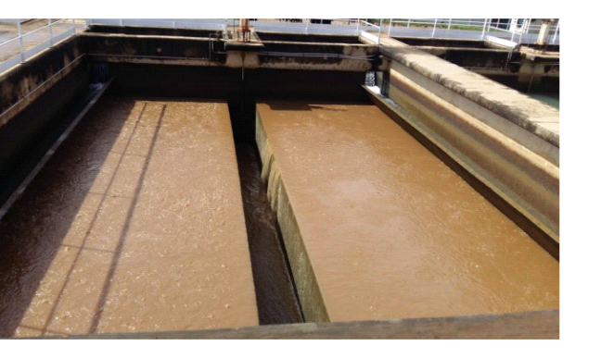

**Fig 2.2. 6 Filter bed undergoing backwashing**

**Attention**

Clear well tank level should reach 2.5m before carrying out backwash of the filters.

**2.1.7 CLEAR WELL TANK**

This is an inbuilt tank in which all the treated water are stored and has the capacity of occupying water to about 10 million gallons.

**SUCTION TANK**

This is also an inbuilt tank and it is designed to make pumping easy for the highlift pumps due

to the location.

**2.1.8 HIGHLIFT PUMP STATION**

This is where the treated water are being distributed into various tanks(tank A at banana junction and tank B at along mount Patti) which are located within lokoja town with the help of the pumps. These pumps comprises of electrical and mechanical and both work together. Here is the description of the pumps:-

Highlift pump installed 6

Number of active. 4 due to power voltage

Type KSB Double entering centrifugal pump: omega 200-670B

Speed 325r/min

Head 118m

Capacity 625m³/hr

Power 325kw

Manufacture KSB Shsngai pump Co. LTD.

Production rate(6 hours) I. e output:

Pump capacity × number of active pumps × time

625 × 4 × 6 = 15,000m³ equivalent to 15 million liters.

Tank A capacity size 5.5 meter × 2,500 = 13.750 liters

Tank B capacity size 3.5 meter ×2,500 = 8.750 liters.

**OPERATION OF THE HIGHLIFT PUMPS BEFORE AND WHILE WORKING**

Before working

* Check carefully for any burn wire, and observe any strange smell and fault of any pumps.
* Check the connecting bar for any fault, which may include loose nut and changing to black color
* Check the fault indication light, voltage and electric current
* Check the pump electric machine for freeze and water leakage.
* Check the compressor, remove water and observe the sound when working. Also check the oil guage, the level should be more than half but not full, and should not fall below half in case of abnormal sound, loose the filter and dust it.

**While working**

* Check the water seal and ensure there is no leakage and check the cold pipe, inlet and outlet valves.
* check the temperature of the pumps by hand touch and also the electric cables, stop pump when notice over heat.
* Check oil leakage and the bearing temperature. The temperature should not be more than 70°c, above 90°c will damage the pump. Check temperature when taking pump readings at 30 minutes interval. Stop pump in case in case of heat and report immediately.
* Always check the drain out water from the drainage chamber by starting the drainage pump.

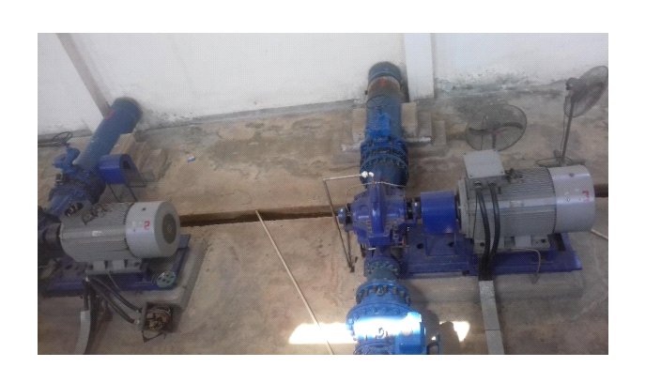

**Fig 2.2.7 Highlift pumps**

**SURGE TANK**

This is a pressurized tank (70% air and 30% water) designed in order to prevent water harmer.

Water harmer is the forcedly return of the lifted water due to an electrical or mechanical failure

thereby damaging the lifting pumps.

**2.1.9 GENERATOR HOUSE**

This is where heavy duty generators are mounted. This generators make use of diesel and serve as standby as standby in a situation where there is no power supply and there is a need to carryout treatment. It is capable of distributing light for the whole establishment. Here is the

description of the generator :-

product milkano 60Kva Generator

Voltage 400v

3 phase

Power factor (PF) 0.8

Current 84A

Frequency 50Hz

Speed 500r/min

**OPERATION OF THE GENERATOR**

**Start**

* Check and measure the water and oil level of the generator, ensure that the radiator is

full with water and diesel 4/5.

* Check and ensure that the battery is connected correctly and the voltage above 25 volt.
* Turn the power switch of the generator.
* Turn on the synchronize power on.
* Insert the key in the cabinet circuit breaker
* 1 generator carries 2 highlift pumps and 1 intake.

**Stop**

* Ensure that all pumps are stop.
* Stop the synchronize switch.
* Wait for 5 min. for generator to automatically stop.
* Turn the load demand switch off.
* Turn the power switch of the generator OFF
* Switch off the ignition

**2.1.10 THE POWER HOUSE**

The main source of the power is Abuja Electrical Distribution Company (AEDC) and it make use of a transformer. It distribute and controls the whole operation of the plant with the help of a control panel board which contains:-

* Power meter(generator & transformer) : it indicates the amount of voltage produced by

the gen. & transformer.

* Voltmeter (generator & transformer) : it display the amount of voltage consume by the

plant.

* Cabinet circuit breaker (generator & transformer) : its for powering or switching on the

light for the plant.

* Capacitor compensation : its used to maintain the voltage power factor.
* Controller : it shows details about power voltage.
* Simatic multi panel(SMP) : it displays the level of water in the clear well & suction tank,
* the turbidity, the pH level, the free chlorine residual e. t. c.

**OPERATION OF THE POWER HOUSE**

* Check the voltage and drain out water(ions) from the pump.
* Check the pumps and valves and ensure there is power(light) in the control box.
* Check the switch
* Check the current after starting the pumps.
* Always check the voltage to know how many pumps will work in pump house and intake. If clear water tank level is above 2.6m and frequency is normal, consider the

table below :

|  |  |
| --- | --- |
| Power voltage | Number of pumps for pump house and intake unit |
| 1. 410 – 430 | 4 highlift pumps 3 intake pumps |
| 2. 400 – 410 | 3 highlift pumps 2 intake pumps |
| 3. 395 – 400 | 2 highlift pumps 1 intake pump |
| 4. 385 – 395 | 1 highlift pump 1 intake pump |
| 5. 380 – 385 | 0 highlift pump 1 intake pump |

Table 1 Power voltage and number of pumps to be used.

Always stop a pump if the voltage falls below 380.

**2.1.11 THE CONTROL ROOM UNIT**

Control room unit is the most sensible unit of the treatment plant, being the unit where all

activities are monitored base on the information received from different section through the working talking mobile radio & the monitoring control panel and the system interpret the state

of operation.

Color indication and its interpretation (control panel)

COLOR INTERPRETATION

Green At rest

White Running (in use)

Yellow No light (electricity)

Color indication and its interpretation(system)

COLOR INTERPRETATION

Red Running (in use)

Yellow Fault

Red Risk of overflow

Other information read out from the control panel and system include :

* Raw water flow in m³/h
* Raw water pH
* Raw water NTU
* Level/volume of solution in each dissolution tank in chemical unit.
* Volume of water in each filter
* Clear well water level in "meter"
* Tank A water level
* Tank B water level
* Pump current
* Voltage
* Treated water flow in m³/h
* Treated water pH
* Treated water NTU
* Treated water free chlorine

Here are some parameters to be consider

1) The volume of the outlet flow(treated water) should be greater than the raw water flow.

2) Stop Tank A pumps when Tank B water level reach 3.5m.

3) Stop highlift pump when Tank A water level reach 3.5m.

4) Stop raw water intake pump before the clear well reach 3.5m especially when using two or

three pump from the raw water intake to avoid overflow.

**2.2 WATER QUALITY TEST (LABORATORY ANALYSIS)**

The water treatment plant has a process laboratory to ensure that the water treatment

processes are optimized and that the water is safe to meet that standard of World and National

Health Agency. Instruments/Apparatus found in the lab include :

* Weighing balance(electrical & manual) : To know the actual mass or weight of an

object or substance.

* Microscope : Its used to magnify object or to enlarge tiny substance and or micro-organisms.
* Incubator: Is a device used to grow and maintain micro biological culture or cell structure. The incubator maintains optimal temperature, humidity and other conditions such as the carbon dioxide and oxygen content at the atmosphere inside. It is also used to culture both bacterial and eukaryotic cells.
* Mass spectrophotometer: It is used to separate hon of different light, the ions are detected by a mechanism cable of detecting charged particles such as an electron multiplier. It is also used to measure wavelength.
* Desiccators: Are seal able enclosures containing dessicants used for preserving moisture-sensitive items such as cobalt chloride paper for another use. It is used to protect chemicals which are hygroscopic or which react with water from humidity. It is also used to remove traces of water from an almost dry sample.
* Membrane filtration: Is a semi-permeable thin layer of material capable of separating contaminants or that will only allow certain compounds to pass through it. Its a mechanical barrier that uses a straining mechanism only to remove material from the water. If the barrier is intact, no particles larger than the membranes pores size can pass through the filter.
* Water bath: Is a device used to the lab to incubate samples in water maintained at a constant temperature. Temperature may be controlled digitally or by a dial and once set, the water bath cycles on and off to ensure constancy of the temperature.
* Autoclaves: Provide a physical method for disinfection and sterilization. They work with a combination of steam, pressure and time. Autoclaves operate at high temperature and pressure in order to kill microorganisms and spores. They are used to decontaminate certain biological waste and sterilize media, instruments and lab wares.
* Water distiller: Is a water treatment method that produces contaminants free water by converting water vapor before condensing it and returning it to a liquid state. During evaporation process, impurities like bacteria, heavy metals, and arsenic are eliminated because they are unable to turn into steam. As the water transit from liquid to a gaseous state, these contaminants are left behind in the boiling chamber. The distillery then cools the evaporated water, returning it to its liquid state as a mineral-free highly pure water.
* Oven: Is a device with features similar to a pressure cooker that allows the heating of aqueous solution to higher temperature than water's boiling point in order to sterilize the content of the autoclave.
* Bunsen burner: Is an instrument that produce hot, sootless, non-luminous flame. It allows for precise regulation of the mixing of gas and oxygen in its central barrel before combustion, which ignite the flame.
* Flocculator or jar test machine: Is used to determine the efficacy of coagulant needed to be dosed in removing charge particles that are present in raw water.
* Turbidimeter: It is used to measure the amount or volume of floc present in the water.
* Pocket pH meter: It is used to measure the pH level of a water.
* Colorimeter: Is used to measure the free chlorine or total chlorine in water after initial application.
* Thermometer: Is used to measure the temperature of the water.
* The glasswares which includes beakers, conical flask, measuring cylinder, burettes, pipette, petri-dishes, funnel, stirers e. t. c.

**2.2.1 TESTS CARRIED OUT IN THE LAB**

The major tests carried out at the laboratory in GLWTP include :

Physical Analysis

Chemical Analysis

Bacteriological Analysis

* Physical Analysis: The major aim of this analysis is to determine the physical factors like turbidity, pH and temperature.
* Turbidity test: Is the cloudiness or haziness of a water caused by large numbers of individual particles that are generally invisible to the naked eye, similar to smoke in air. Those particles caused the water to appear turbid. The measurement of turbidity is a key test of water quality. The aim if the test is to determine the amount or volume of suspended particles present in the water. The instrument used is turbidimetre and it is measured in Nephelometric turbidity unit(NTU). According to WHO, the standard turbidity of a good drinking water is 3 NTU. It can be less than 3 but anything above 3 means the water is turbid and is not safe to drink.

**Apparatus**

* Beaker
* Sample bottle
* Turbidimetre

**Reagents**

* Water sample (raw or treated)

**Procedure**

* Get your water sample in a clean beaker.
* Filled the sample bottle with water sample to the required level
* Insert the sample bottle into the turbidimetre.
* Wait for some time during which the result will be display on the screen.

**Result**

The turbidimetre will display the turbidity of the water sample e. g 15 NTU.

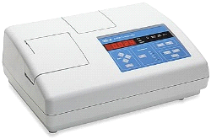

**Fig 2.3.11 Turbidimeter**

* pH test(the potential of hydrogen ions) : This is the degree of acidity or alkalinity of water.

It indicates the concentration of hydrogen ions in water. Water with pH less than 7 are acidic and water with pH greater than 7 are basic. Water with pH of 7 at the temperature of 25°c are neutral (e. g pure water). The pH value can be less than 0 for a very strong acids, or greater than 14 for a very strong bases. According to WHO, the standard pH of a good drinking water has to be neutral (6.5 to 8.5) and it is measured with pocket pH meter.

**Apparatus**

* Beaker
* pH meter

**Reagents**

* Water sample(raw or treated)

**Procedure**

* Half fill the beaker with water sample.
* Insert the pH meter into the beaker.
* Wait for some time during which the reading will be displayed on the meter screen.

**Result**

The pH meter will display the pH level of water sample e. g 7.5.

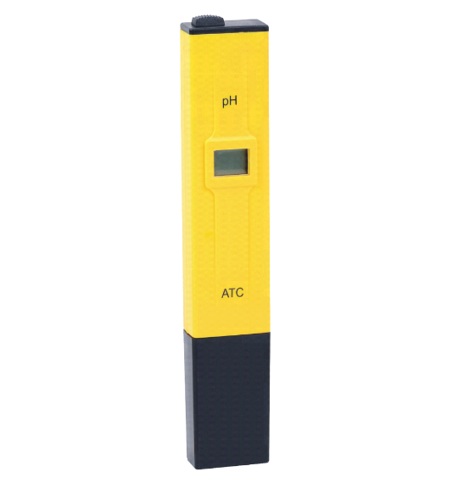

**Fig 2.3.12 Pocket pH meter**

* Temperature test: Water temperature is critical because it is an important quality in environmental parameters. It is important to measure water temperature and by doing so, we can see the characteristics of the water such as the chemical, biological and physical properties of the water, as well as the possible health effect. The temperature of a good drinking water is 15°c. Measurements of temperature for water treatment is made with mercury-filled celcius thermometer.

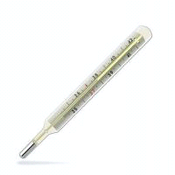

**Fig 2.3.13 Mecury-filled Thermometer**

* Chemical analysis : Is the determination of chemical composition of water. The aim of this analysis is to identify and quantify the chemical component of water sample. It includes flocculation test, chlorine residual test, TDS, TSS and TS.
* Chlorine Residual Test: When chlorine is added to water, some of the chlorine reacts first with inorganic & organic materials and metals in the water and is not available for disinfection (this is called the chlorine demand of the water). After the chlorine demand is met, the remaining is called total chlorine. Total chlorine is further divided into :-
* Combined chlorine, which is the amount of chlorine that has reacted with inorganic and organic nitrogen-containing molecules to make weak disinfectant that are unavailable for disinfection.
* Free chlorine, which is the chlorine that is left over and is available to inactivate disease-

causing organisms.

The goal of dosage testing is to determine how much chlorine (sodium hypo chlorite solution) to add to water that will be used for drinking to maintain free chlorine in the water for the average time of storage of water in the household. According to WHO, a residual concentration of free chlorine shouldn't be greater than 0.5mg/L which is equivalent to 0.5ppm. Colorimeters are the most accurate way to measure free chlorine or total chlorine residual.

**Apparatus**

* Beaker
* Calorimeter
* Sample bottle

**Reagents**

* Water sample (treated)
* Diethylphenyldiamine (D P D) tablets

**Procedure**

* Get your water sample in a clean beaker.
* Fill the sample bottle with water sample. Add D P D tablets which cause the color change to pink.
* Insert the sample bottle containing the reagents into the colorimeter.

Result : The colorimeter reads the intensity of the color change by emitting a wavelength of light and automatically determining and displaying the color intensity digitally. The range of the meter is 0 - 4mg/L or 0 - 4 ppm.

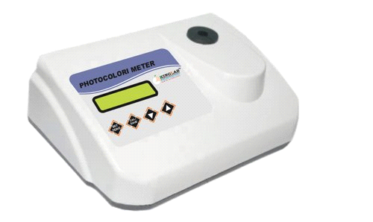

**Fig 2.3.14 Colorimeter**

* Jar or Flocculation test: The purpose of the test is to know the efficacy or to select the type of coagulant(alum) and also to estimate the optimal dose needed in removing charged particles that occurred in raw water. Jar test is an experiment to understand the process of coagulation, flocculation and sedimentation. In a standard practice, jar test involve rapid mixing, followed by slow mixing and later the sedimentation process.

**TO DETERMINE THE NUMBER OF BAGS OF ALUM TO DISSOLVE**

Things to consider :

* Size of the Dissolution tank = LENGTH ×BREATHE×HEIGHT = 6m³
* 10% of the flow rate = 1000/10 = 100
* Weight of the bag of Alum = 50KGS

Formula = Tank size × 10% flow rate/weight of the bag

= 6×100 /50 = 600/50 = 12bags

**Preparation of alum solution**

Preparation of alum solution is dependent on the turbidity of the raw water. Turbidity of 200NTU or below, 5gs of alum solution is needed while 200NTU and above, 10gs of alum solution is needed.

To prepare 10gs alum solution

**Apparatus**

* Weighing balance
* Alum
* Beaker
* 1000mls deionized water/distilled water

**Procedure**

* Weigh 10g of alum using a weighing balance SS
* Fill the beaker with deionized water to a level of 1000mls
* Dissolved completely the 10g of alum in the 1000mls of deionized water. Then you have

10g alum solution.

**TO CARRYOUT JAR TEST**

**Apparatus**

* 1000mls graduated cylinder
* Jar test machine
* Time piece
* Beakers(the number of beakers can be anywhere from 4 - 6)

**Reagents**

* 5gs or 10gs of alum solution depending on the turbidity
* Water sample (raw water)

**Procedure**

* Using a 1000mls graduated cylinder, add 1000mls of raw water to be coagulated to each

of the jar test beakers.

* Pipette in each beaker with increasing amount of alum solution I. e beaker 1:2 mls, beaker 2: 4mls, beaker 3: 6mls, beaker 4: 8mls, beaker 5: 10mls, beaker 6: 12mls.
* Turn on the stirrer, operate the stirrer vigorously for 1min. to stimulate the static mixer.
* Then reduce the speed of the stirrer to match the condition of the flocculator.
* Allow the operation to last for another 29min. making the whole operation to last for a

period of 30min.

* Off the stirrer and leave the setups for a couple of hours.

**Note:**

An underfed with alum cause the sample to look cloudy with little or no flocs and almost no settling, while an overfed with alum cause a dense fluffy flocs to occur and will not settle well. The beaker with the appropriate dosage of alum(coagulant) will have flocs that has settled to the bottom and the above water will be clean.

Then look at the beakers and determine the best result. Here are the factors to consider

when determining the best result.

* The rate of coagulation or flocs formation.
* The amount of settling.
* The rate of the clear surface.
* The turbidity of each beakers
* Beaker 1 with 2ml of alum solution -------------21NTU
* Beaker 2 with 4ml of alum solution -------------2NTU
* Beaker 3 with 6ml of alum solution -------------3NTU
* Beaker 4 with 8ml of alum solution -------------8NTU
* Beaker 5 with 10ml of alum solution -----------9NTU

Best result(Br) = beaker 2 with 4ml × 10g of alum used

Br = 40

Formular

Br × rate of water flow × % of alum in dm³ / time in secs

= 40 × 1 × 10 / 60 = 400/60 = 6.7L/m pump delivery.

Pulse and Frequency

pulse ranges from 1 ----- 100%

Frequency ranges from 1 ----50%

Formular 6.7 × 1/50 × 1/100

To get frequency

6.7/1 × ? /50 × 100/100 = 6.7

6.7 × ? × 100 = 1 × 50 × 100 × 6.7

670 = 33,500

670/670 = 33,500/670 = 50

Frequency = 50

To get pulse

6.7/1 × 50/50 × 100/100 = 33,500/5000 = 6.7

3. Total dissolved solids(TDS)

Total dissolved solids is a measure of the dissolved combined content of all inorganic and organic substance present in a liquid in molecular, ionized or micro-granular(colloidal son) suspended form. TDS concentrations are often reported in ppm. The operational definition is that the solids must be small enough to survive filtration through a filter with 2- micrometer (nominal size or smaller) pores.

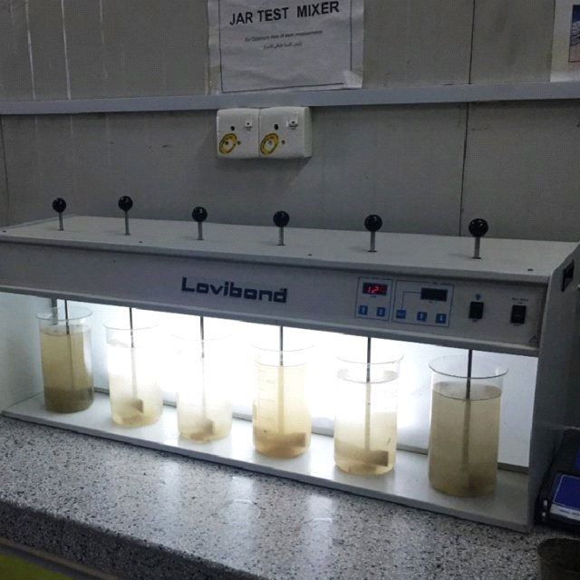

**Fig 2.3.14 Flocculation/Jar test machine.**

* Total Dissolved Solids(TDS)

Total dissolved solids is a measure of the dissolved combined content of all inorganic and organic substance present in a liquid in molecular, ionized or micro-granular(colloidal son) suspended form. TDS concentrations are often reported in ppm. The operational definition is that the solids must be small enough to survive filtration through a filter with 2- micrometer (nominal size or smaller) pores.

**Gravimetric analysis of TDS**

**Aim:** To determine the TDS of a given water sample.

**Apparatus :** Filter paper(whattman no - 42), beaker, hotplate, physical balance, funnel,

measuring cylinder, desicator, oven.

Reagent: water sample (treated)

**Procedure :**

* Dry the beaker in oven(105°c) and cool in desicator then weight it.
* Take 300ml of filter sample in this beaker and evaporate up to dryness on a hotplate,
* cool in a desicator and weight it. Repeat the above procedure twice.

Calculate the TDS using formular:-

W2 - W1 × 1000/v

Where,

W1 = initial weight of beaker

W2 = final weight of beaker

V = volume of sample

Observation table:

|  |  |  |  |  |
| --- | --- | --- | --- | --- |
| **S/No** | **Sample description** | **Initial weight of beake, W1 (mg)** | **Final weight of beaker, W2(mg)** | **TDS ( mg/l)** |
| 1 | 1 | 280.66 | 280.67 | 0.033 |
| 2 | 2 | 280.66 | 280.68 | 0.066 |
| 3 | 3 | 280.66 | 280.69 | 0.01 |

Table 2. TDS observation table

Result : The total dissolved solids of a given water sample was observed to be 0.0367gm/l

Precautions :-

* Glasswares should be clean
* Weight the beaker carefully.
* Note the weight carefully.

4. Total suspended solids (TSS)

Total suspended solids is the dry weight of suspended particles that are not dissolved in a

sample of water, that can be trapped by a filter and is analyzed using filtration apparatus. It is a

water quality parameter used to access the quality of a specimen of any type of water or water

body, ocean water or waste water after treatment.

**Gravimetric analysis of TSS**

Aim: To determine the TSS of a given water sample.

Apparatus : Filter paper(whattman no-41), beaker, hotplate, physical balance, funnel, measuring cylinder, desicator, oven.

Reagent : water sample (treated)

Procedure :

* Dry the filter paper in oven(105°c) and cool in desicator then weigh.
* Filter 300ml through filter paper, keep the filter paper over night to dry.
* Cool the filter paper in desicator and weigh it. Repeat the above procedure twice.

Calculate the TSS using formula:- W2 - W1 × 1000/v

Where,

W1 = initial weight of filter paper

W2 = final weight of filter paper

V = volume of sample

Observation table :

|  |  |  |  |  |
| --- | --- | --- | --- | --- |
| **S/No** | **Sample description** | **Initial weight of filter paper, W1 (mg)** | **Final weight of filter paper, W2 (mg)** | **TSS (mg/l)** |
| 1 | 1 | 0.85 | 2.96 | 7.03 |
| 2 | 2 | 0.85 | 2.95 | 7.00 |
| 3 | 3 | 0.85 | 2.97 | 7.07 |

Table 3. TSS observation table

Result : The total suspended solids in a given water sample was observed to be 7.033mg/l.

Precautions :

* Glasswares should be clean.
* Weigh the filter paper carefully
* Note the weight carefully.

5. Total solids (TS)

Total solids (TS) are a measurement often used in the water treatment plant that includes the combination of total dissolved solids and total suspended solids in a liquid. Total solids are composed of all the suspended, colloidal and dissolved solids in the sample. This mixture includes any dissolved salts such as sodium chloride (NaCl) and solid particles such as silt and plankton.

A high total solids level indicates that there is a high level of solid material in the liquid sample. Depending on the evaluation criteria, a high level of total solids could cause the sample

to be considered contaminated.

**Gravimetric analysis of TS**

Aim: To determine the TS in a given water sample.

Apparatus : porcelain dishes, measuring cylinder, physical balance, and oven.

Reagent : Water sample

Procedure :

* Weigh the previously dried empty porcelain dishes(w1) already kept at 105°c in the oven for two hrs and in desicator for 30 minutes.
* Take 100ml well mixed sample in each porcelain dishes and place the porcelain dishes in

the oven at 105°c carefully for 24 hrs.

* After 24 hrs, take the dishes out and keep in desicator for 30minutes for cooling. Now weigh the porcelain dishes and note the final weight(W2). Repeat the procedure of weighing and drying till constant weight is achieved.

Calculate TS using formular:- (W2 - W1) × 106 / sample volume.

Observation table:

|  |  |  |  |  |  |
| --- | --- | --- | --- | --- | --- |
| **S/No** | **Sample description** | **Initial weight, W1**  **(mg)** | **Final weight, W2**  **(mg)** | **TS (mg/l)** | **Average TS** |
| 1 | 1 | 110.38 | 110.74 | 3,600 | 1,800 |
| 2 | 2 | 110.38 | 110.54 | 1,600 | 800 |
| 3 | 3 | 110.38 | 110.75 | 3,700 | 1,850 |

Table 4. TS observation table

Result : Total solids in the given water sample was found to be 2966.67mg/l at 105°c.

Precautions :

* Glasswares should be clean.
* Cool the dish properly.
* Note the weight carefully.
* Bacteriological analysis:Bacteriological water analysis is a method of analyzing water to estimate the numbers of bacteria present and if needed to find out what sort of bacteria they are. It represents one aspect of water quality. It is a microbiological analytical procedure which uses samples of water and from these samples determines the concentration of bacteria.

Aim: To determine the presence of bacteria in water sample

Apparatus : conical flask, pipette, petri-dishes, weighing balance, spatula, microscope,

autoclave, water bath, aluminum foil, wash bottle.

Reagents: Distilled water, Agar media.

Procedure :

* Calculate the amount of agar to be used for a particular volume of distilled water following an already stated value e. g 28g in 1000ml.
* Weigh out the calculated amount and dissolve in the volume of distilled water(50ml).
* Cover with a cotton wool and aluminum foil, heat temporarily on a water bath to mix homogeneously. A conical flask should be used for heating in autoclave for 15 minutes.

**Analysis using spread plate method**

* Bring out immediately after autoclaving and allow to cool for 45 minutes. Check the temperature with your skin. If tolerable, it has cooled to a minimal temperature.
* Put in a petri dish and allow to gel, allow to solidify and immediately introduce the sample to be analyzed. If the sample is raw water, use serial dilution method but if it is already treated water, use 0.1ml and spread on the surface of the agar in the petri dish.
* Incubate for 48 hours then observe the bacterial growth with the aid of a microscope analysis using pour plate method
* Add sample into petri dish and the agar which has been cooled to 40°c or 45°c into it allow to solidify.
* Incubate for 48 hours. Observe the bacterial growth with the aid of a microscope.

**Note:**

If bacterial growth is not observed after the procedure is completed, repeat the experiment.

**Observation:**

Bacterial growth was observed

**Conclusion:**

The water is unfit for drinking due to the presence of bacterial, therefore the dosage of calcium hypo chlorite is deemed insufficient.

**2.3 WORKING EXPERIENCE**

During my stay at KGSWB/GLWTP, the abilities and knowledge that were acquired during the course of this training exercise includes being able to make modifications to the process of water purification and test it quality (analysis) before distribution .Also, Water is a valuable commodity and the society cannot do without it. My stay at KGSWB/GLWTP taught me how to monetize what I have been taught and also to make life better through the application of the principles of chemistry.

**2.3.1 WATER TREATMENT PROCESS**

Water treatment is any process that improve the quality of the water to make it appropriate for a specific end-use. The end-use may be drinking, industrial water supply, irrigation, river flow maintenance water recreation e. t. c. Water treatment removes contaminant and undesirable components, or reduce their concentration so that the water become fit for it desired end-use. This treatment is crucial to human health and allows human to benefit from both drinking and irrigation use.

The five (5) major process in water treatment plant include

* COAGULATION: Is the reaction between the coagulants(typically Aluminum sulfate) and the water. Al2(SO4)3 +6H2O

The positive charge of the coagulant neutralize the negative charge of dissolved and suspended

particles in the water. When this reaction occurs, the particles bind together. The van der waals

force will cause the particles to cling together (agglomerate) and form a micro floc.

* FLOCCULATION : Is a process that causes the small coagulated particle to form larger

particles or floc which are heavily and quickly settled. The floc formed creates a surface in

which the particulates in the water adsorb(adhere) to the surface of the floc thus forming

larger settle able particles for easy removal by sedimentation and filtration.

* SEDIMENTATION : Is a process that remove suspended solids(particles) that are denser than the water and to reduce the particulate load on the filters. Sedimentation is accomplished by decreasing the velocity of the water being treated below the point where it can transport settle able suspended particles, thus allowing gravitational forces to remove particles held in suspension. When water is almost still in sedimentation basins, settle able solids will move toward the bottom of the basin. This sedimentation process remove almost 90% of the solids in the water. The clearer water on the surface is collected in the collector that direct the water to the filter gallary to remove the remaining 10% solids.
* FILTRATION : Is a process that remove particulate impurities that were not remove during sedimentation process. The plant uses gravity sand filter beds. The filter beds comprised of anthracite or quartz sand of various sizes; the fine, finer and finest. The top layer which is fine, the middle layer which is finer, the bottom layer which is finest and an underdrain system(out let) that collect the filtered water.
* DISINFECTION: This can be pre chlorination or post chlorination. Calcium hypochlorite is added to the water at the pre-chlorination point to begin the disinfection process. The disinfection process is designed to kill or inactivate most micro organisms in water, including essentially all pathogenic organism whether they are from bacteria, viruses or intestinal parasites. Pathogenic organisms are the microscopic bugs in water that can cause water borne diseases such as gastroenteritis, typhoid, dysentery, cholera and giardiasis.

**CHAPTER THREE**

**PROBLEM ENCOUNTERED, AND SUGGESTIONS**

**3.1 PROBLEMS ENCOUNTERED**

Although my six months Industrial Training was a success, but I cannot deny the fact that I have encountered some challenges in the course of the training. These challenges include.

**1. Laboratory problem**

The major problem I faced during my stay in GLWTP was that students are not really

exposed to laboratory analysis. Although we do change unit/section every week but with the

exception of lab and which is very important to our field of study.

**2. Lack of safety wears**

Lack of safety wears was another challenge that I faced during the training program. Since I started the training I have never used hand gloves. My hands were always bared when mixing chemicals and when carrying out analyses. And we usually used chemicals that are very harmful to our skin.

**3. Financial constraints**

From the organization where I undertook my SIWES program to my residential place is a long distance. So I really spent so much just to transport myself to and from my place of attachment. There was a day I have to missed going to work due to transport fare issue.

**3.2 POSSIBLE SUGGESTIONS**

* I suggest that laboratory unit should be included to the major five units visited by student every week as this will enable them to perform the analysis by themselves and to also know the quality of the water being distributed to the town.
* I suggest that the state government should consider GLWTP for rehabilitation and proper maintenance of the plant.
* I also suggest to Industrial Training Fund(ITF) that they should review the policy of paying allowance to student on industrial training. The policy should be in such a way that the student will be given small stipend every month when he or she is still on the training program.

**CHAPTER FOUR**

**SUMMARY, CONCLUSION AND RECOMMENDATION.**

**4.1 SUMMARY**

This technical report covers in its entirety all what I learnt during the compulsory six (6) month Students Industrial Work Experience Scheme (SIWES) as institutionally sponsored and implemented by the Industrial Training Fund (ITF)

The Scheme had made it possible for me to have first-hand knowledge on conventional water treatment process and water quality tests which constitute bacteriological analysis, chemical analysis and physical analysis.

**4.2 CONCLUSION**

My six (6) months industrial attachment at Greater Lokoja Water Treatment Plant was a huge success and a great time of acquisition of knowledge and skills. Through my training I was able to appreciate my chosen course of study even more, because I had the opportunity to blend the theoretical knowledge acquired from school with the practical hands-on application of knowledge gained here to perform very important tasks that contributed in a way to my productivity in the plant. My training here has given me a broader view to the importance and relevance of biologists in the immediate society and the world as a whole, as I now look forward to impacting it positively after graduation. I have also been able improve my communication and presentation skills and there by developed good relationship with my fellow colleagues at work. I have also been able to appreciate the connection between my course of study and other disciplines in producing a successful result.

**4.3. Recommendations**

It is recommended that different organizations should be highlighted more about the scheme to ease the training of students.

It is also recommended the continuity of the student industrial work experience scheme (SIWES) as it has helped to bridge the gap between theory and practical knowledge of students.

Also, it is recommended that government should mandate and encourage relevant agencies for improvement.

**REFERENCES**

C.A.Kamolafe, B.S.Agboola, A.O.D. Adejumo and J.B. AreolaModern Conventional Water Treatment Technologies And Challenges For Optimal Utilization In Nigeria. Journal.

Clark R.M, and Tippen.D.L (1990); water supply in corbittr, Ed. Standard Hand book of Environmental Engineering,New york Mc Graw-Hill; pp5.1-5.225.

DeZuane,John (1997).Handbook of Drinking water Quality (2nd ed.). John wiley and sons. ISBN 0-471-28789-X.

Greater Lokoja Water Treatment Plant manual book.

Moran,Joseph M.; Morgan, Micheal D., & Wiersma,James H. (1980). Introduction to Environmental Science (2nd ed). New york: W.H. Freeman.

My logbook.

Safe water for the community:A guide for establishing a community-based safe water system program (2008).

Audu Umoru Bsc Hons microbiology.